ANALYSIS: Day of Month field – Account Details screen

Test Env: <https://teiab-commercial.test.grangeinsurance.com:8580/bc/BillingCenter.do>

Acct # 1000042393– Created account/policies on account level bill responsive, changed to non-responsive.

Acct # 8285846824 – Created account/policy on policy level bill responsive, changed to non-responsive via overriding on invoice streams tab.

Tests:

* Policy level bill – responsive : hit “edit” on account details screen : Results – these fields are not showing on screen

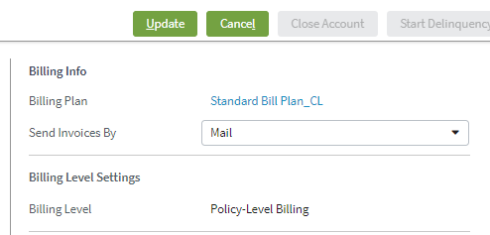

QUESTION FOR DIOR: Verify this is expected and no changes needed– Yes working as expected, no changes needed

* Policy level bill – non-responsive : hit “edit” on account details screen : Results – these fields are not showing on screen

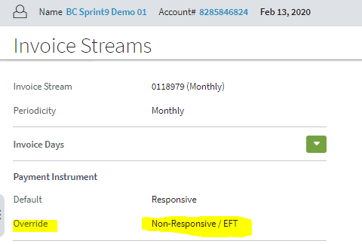

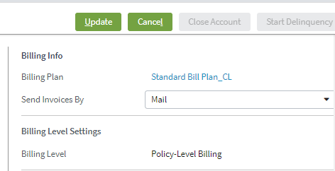

QUESTION FOR DIOR: Verify this is expected and no changes needed – Yes working as expected, no changes needed

* Account level bill – responsive : hit “edit” on account details screen : Results-user can modify ‘Day of Month’ field

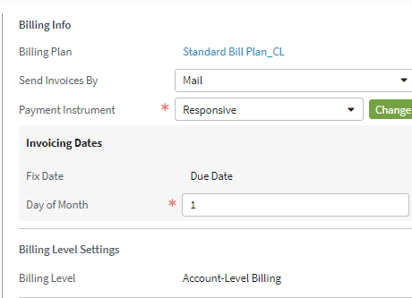

QUESTION FOR DIOR: in this scenario should what needs changed? – We want to show entire invoicing dates section still but make ‘day of month’ non editable when payment instrument = responsive.

* Account level bill – non responsive : hit “edit” on account details screen : Results-user can modify ‘Day of Month’ field

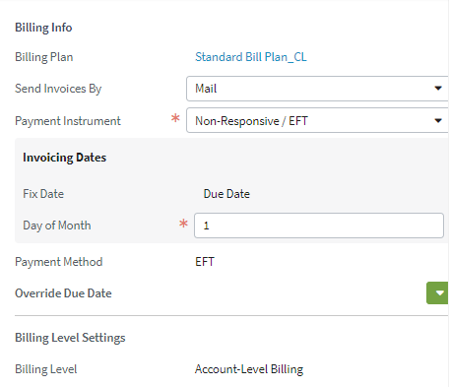

QUESTION FOR DIOR: in this scenario should what needs changed? For cleanliness we should 1) make day of month field non-editable and 2) Hide Invoicing Dates section when payment instrument = non-responsive.